Food App Template compilation manual

This application can be run on Android or iOS operating system.

Also you can use APK file if it is not about development. [LINK](https://drive.google.com/file/d/1BM_WSu1Qkij0GLHyTWZWtmOSWisvY11z/view?usp=sharing)

It is more convenient to use the "Expo" technology for development.

Follow the instructions below.

In case of any problem feel free to contact our developer Iliya by Email: [zabaron@gmail.com](mailto:zabaron@gmail.com) or by phone +972-546800559.

1. Running using Expo

Simple way with ready compiled app:

1. Download the ready compiled app by [LINK.](https://github.com/Iliya-hacker/recipes-app-react-native)
2. Install expo cli globally by running npm install -g expo-cli Follow the instruction here: <https://docs.expo.io/>
3. For installation components run **npm i** or **yarn** using command line.
4. Install Expo Go on your smartphone. It is available in Apple store: [LINK](https://apps.apple.com/ru/app/expo-client/id982107779)

and in Google Play as well: [LINK](https://play.google.com/store/apps/details?id=host.exp.exponent&hl=ru&gl=US).

1. For start run **expo start** using command line. (Command **npm** **run start** works only in case of raw not compiled app as described below in “long way” instruction.)
2. In window that opens you have several options: *Run on you device, run on Android device/emulator* or *run on iOS simulator.* **Note: if the window does not open just copy and paste the URL from command console.** Example:****
3. To run on a device open Expo Go App and scan a QR-code will appear in the window that opens. The project will be open on your smartphone or tablet.
4. To run on Android emulator use this step by step instruction for setting environment: [LINK.](https://reactnative.dev/docs/environment-setup) Then run Android Studio and run AVD emulator. Then run **expo start** and press button **run on Android device/emulator** in the window that opens. In case of error try **yarn start --reset-cache.**
5. To run on iOS simulator use this step by step instruction for setting environment: [LINK.](https://reactnative.dev/docs/running-on-device) Then run **expo start** and press button **run on iOS simulator** in the window that opens.
6. If you need to make any changes to the composition of the App components, edit the **files in data folder**. You can edit the code in any code editor while the app is running.

Long way with raw original app:

1. Download the original app from the store by link: <https://www.instamobile.io/app-templates/food-app-template/>
2. Install expo cli globally by running npm install -g expo-cli Follow the instruction here: <https://docs.expo.io/>
3. Open the project in VS code or in other code editor.
4. Check package.json file and ensure that expo version not less than 37.0.0. If not - change this.
5. In app.json file ensure that sdk Version not less than 37.0.0. If not - change this (minimum required version is 37.0.0).
6. Perform steps from 3 to 7 from previous instruction (simple way with ready compiled app) and you can use **npm run start** command.

*Example of running on Android emulator using Expo*

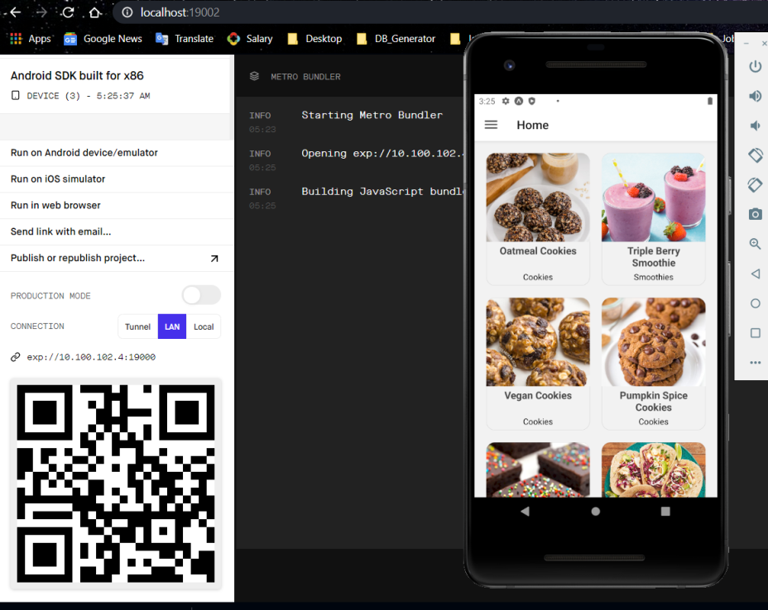

1. Running without Expo using react native environment

Simple way with ready compiled app:

1. Download the ready compiled app by [LINK.](https://github.com/Iliya-hacker/recipes-app-react-native)
2. For installation components run **npm i** or **yarn** using command line.
3. To run in android emulator open android studio then browse to the project and open the “android” folder. [LINK.](https://reactnative.dev/docs/environment-setup) Ensure that you have Java pre installed.
4. Run npx react-native start **and then** npx react-native run-android in command console and the project will be run in android emulator.
5. To run on iOS simulator use this [LINK.](https://reactnative.dev/docs/environment-setup)
6. To run on Android or iOS devices use this step by step manual: [LINK.](https://reactnative.dev/docs/running-on-device)

Long way with raw original app:

1. Download the original app from the store by link: <https://www.instamobile.io/app-templates/food-app-template/>
2. For installation components run **npm i** or **yarn** using command line.
3. Run **npm** **run eject** or **expo eject** for creating android and iOS folders. When the system will ask you give name for android repository in following format: *anyname.myapp*.
4. Perform steps from 3 to 6 from previous instruction (simple way with ready compiled app).

***Happy hacking!***